

New Home Buyers Guide

**Compiled & Published by Samir Shaik**

shshaik@gmail.com

Contents

Utilities 3

Duke Energy 4

Dominion Energy 6

City of Concord 7

Before you buy online 8

Home Security 9

Door Latch 11

Grout Sealing 12

Water Repellant for Shower Glass Closet 14

Home Networking 15

Handyman Tools 16

Stop scratches on hardwood floor 17

TV wall mount 18

Carpet Care 19

Hardwood Cleaning 21

# Utilities

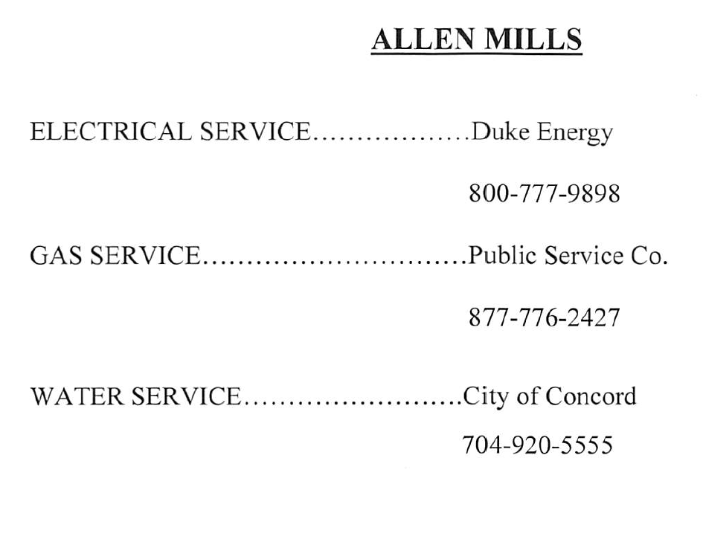

## Duke Energy

1. You should get letter from Duke Energy with your Account Number.
2. Go to <https://www.duke-energy.com/home>
3. Click on “Register” link as show in image below
4. On the next page select “Yes, I have service> link
5. Next select Home radio button and click on “Continue” button
6. Enter the Account Number or any other personal information to continue on the next page
7. If your account is retrieved successfully, the next page will ask for your email address
8. On the next page enter your email address, security PIN, Agree T&C and click on “Register” button
9. You should receive email to verify and let you sign in to the account
10. After sign-in you can enroll in paperless billing, change other preferences and also pay online
11. Note that Duke Energy has apps for your smart phone too

Not all screens have been captured for brevity and security reasons

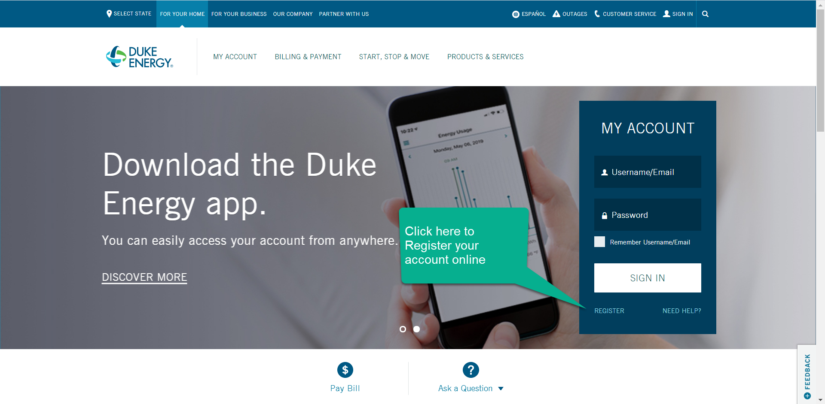

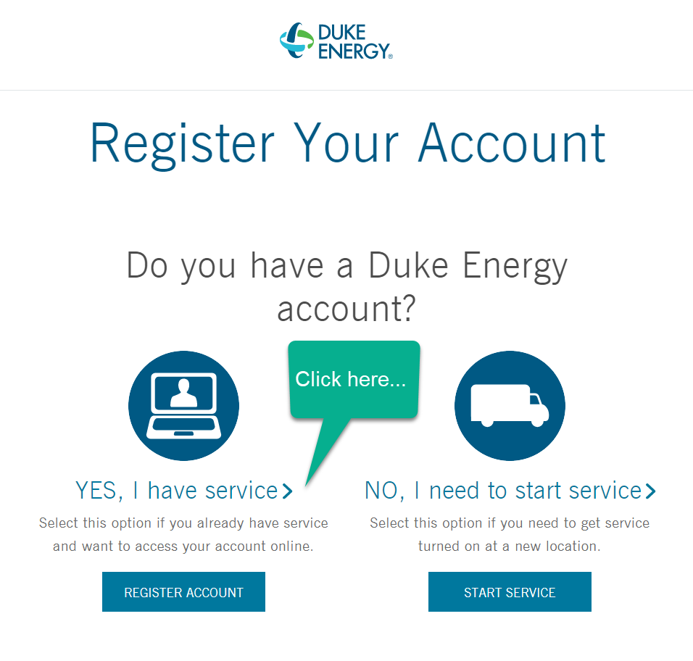

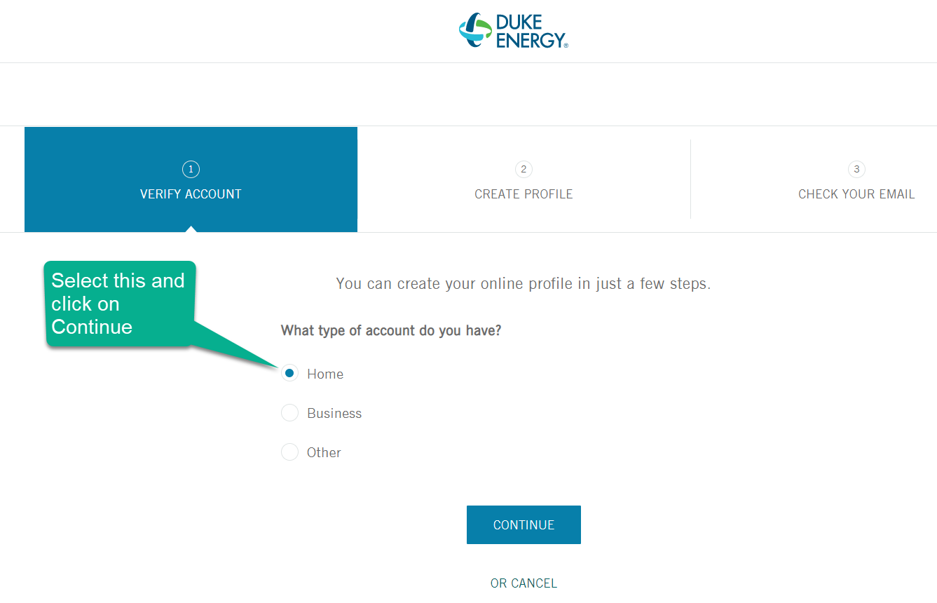

## Dominion Energy

When you call in to enroll in gas service with Dominion Energy, they will request you for your email address and send you details on registering online. Just follow the email to get online account.

Please note you can also download app for your smart phone. You can enroll in paperless billing and setup bank account for automatic payments.

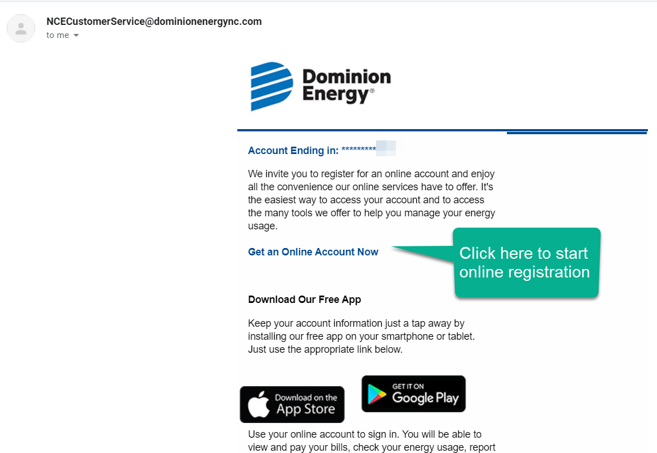

## City of Concord

To transact online with City of Concord you need the account number and PIN which you should be able to get by calling in the customer care.

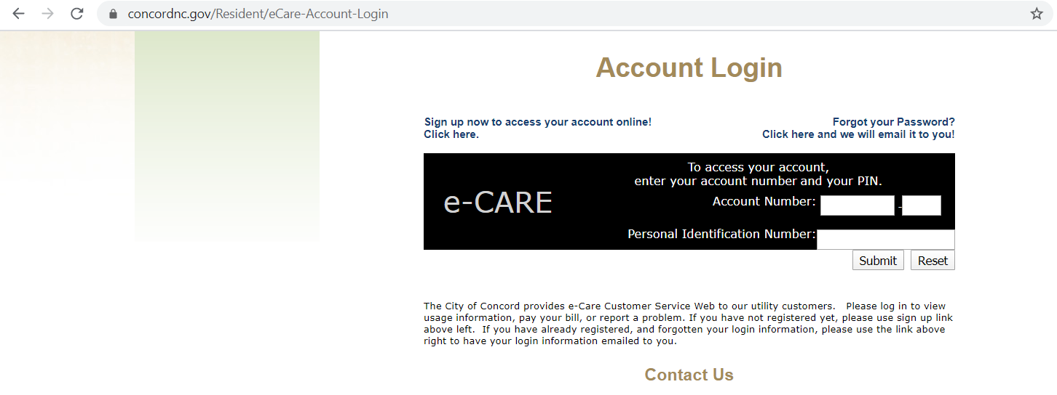

# Before you buy online

**Can you trust an online store?**

Before you buy from any store, it’s a good idea to get to know about them. <https://www.trustpilot.com/> is a good site to see how much trust/goodwill the store has gained based on reviews of customers who have done business with them before. You can sign-up and share your own experience with others who could benefit if you will to.

If you are shopping for furniture, there are several stores online and in your vicinity. Some of the stores I checked online are listed below:

1. Macy’s Furniture
2. LA-Z-BOY Furniture
3. Ashley Furniture
4. Rooms-To-Go
5. Way Fair Furniture
6. Value City Furniture
7. Overstocks
8. Amazon

# Home Security

**SimpliSafe (**<https://simplisafe.com/>)

Reason for choosing SimpliSafe?

1. A lot of my friends were already using it and had shared good experience
2. There is no contract
3. Basic charge is at $14.99 and advanced monitoring charge is at $24.99
4. Got a very good deal with 30% off and $50 rebate for using my Amex credit card
5. A lot more devices integrated to single base station. SimpliSafe has following devices at the moment that integrate with their base station:
   1. Entry Sensor (these are to be installed on the doors)
   2. Motion Sensor (these are to be installed where you expect immediate entry motion when someone enters your home from any of the available entries)
   3. Glass Break Sensor (these are to be installed close to the glass windows or doors on the first floor, a breaker takes care of all windows that are 20 feet away or as mentioned on the installation document)
   4. Indoor Camera (installed inside the home, mostly facing the entry door)
   5. Outdoor Kit (If you need to install camera for external monitoring)
   6. Video Doorbell Pro
   7. Smart Lock
   8. Key Fob (this is what you can carry on you in the car to arm/disarm the system)
   9. 105dB Siren
   10. Freeze Sensor
   11. Water Sensor (you need to keep this where you expect water leakage, especially where your washing machine is)
   12. Panic Button (this can be close to your bed in master bedroom, to enable you to activate panic if anyone enters your home and you need to alert)
   13. Keypad (this is the main system that let’s you arm/disarm and setup other configurations for the system)
   14. Carbon Monoxide Detector
   15. Smoke Detector
6. It’s capable of working without electricity for 24 hours and falls back for communication on cellular module in the event WIFI is lost.
7. One standard charge no matter how many devices you add.

**Important Instructions**

* When you open the boxes check to ensure the units are fresh and new. There has been an instance where my friend got old units.
* Remember there are 2 colors for base station and keypad, white and black. When you order make sure you select the color that matches your interior.
* When you activate services with SimpliSafe, you should get an email informing you to register with local police department. It’s important to get this done, else you may end up being fined to the tune of $250 for false alarm police dispatch.

**FAQ Important ones**

1. What happens if I lose power and have no WiFi Connection? Will my Simplisafe system still work?

In the event of a power outage, your SimpliSafe Base Station is equipped with a backup rechargeable battery supply that will keep your Base Station powered for up to 24 hrs. It also features a cellular module that operates without WiFi. The Base Station will automatically communicate on the cellular network if your WiFi stops working.

1. Does the system declare which door is opened in human voice?

No, it does send you secret alert in form of SMS and/or email indicating which door is opened.

**References**

Installation: <https://support.simplisafe.com/hc/en-us/articles/360029871372-Installation-Help-for-the-All-New-SimpliSafe>

# Door Latch

Found this to be very effective and nice looking door latch.

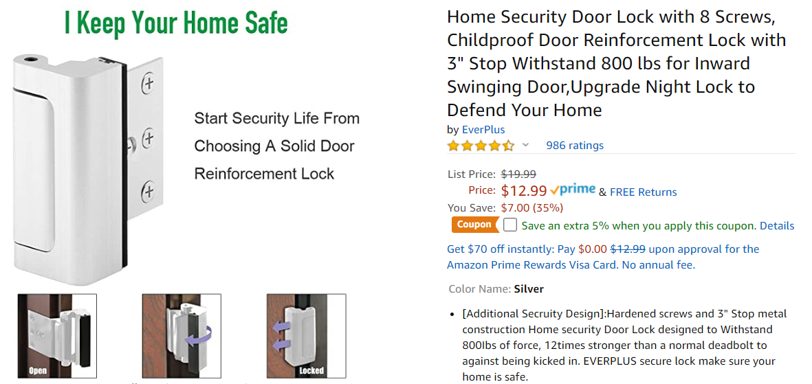

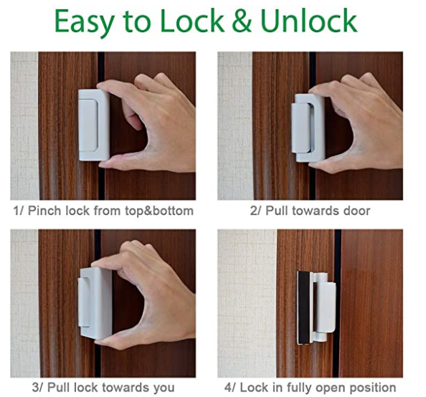

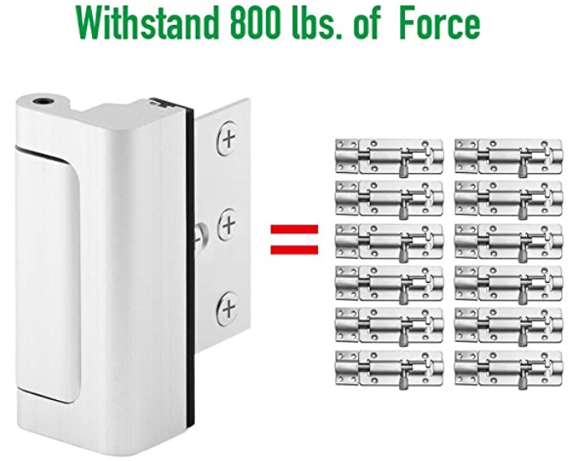

Window and Door Tinting – DIY

# Grout Sealing

This is what we used, but is very expensive for 32 ounces (1/4th of gallon)

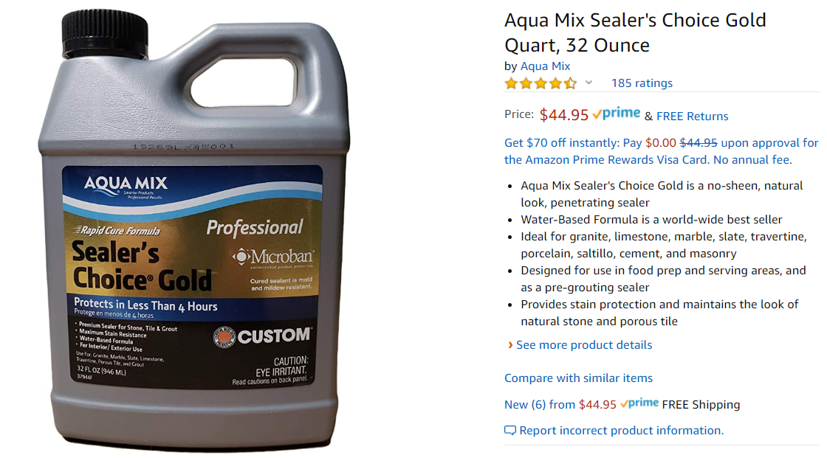

This is available in Lowe’s for $31.48 and has good reviews. And this cost seems to be for a gallon.

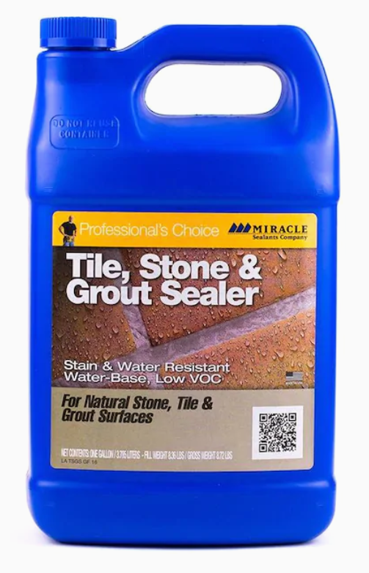

These are good brushes to apply the sealer on the grout accurately.

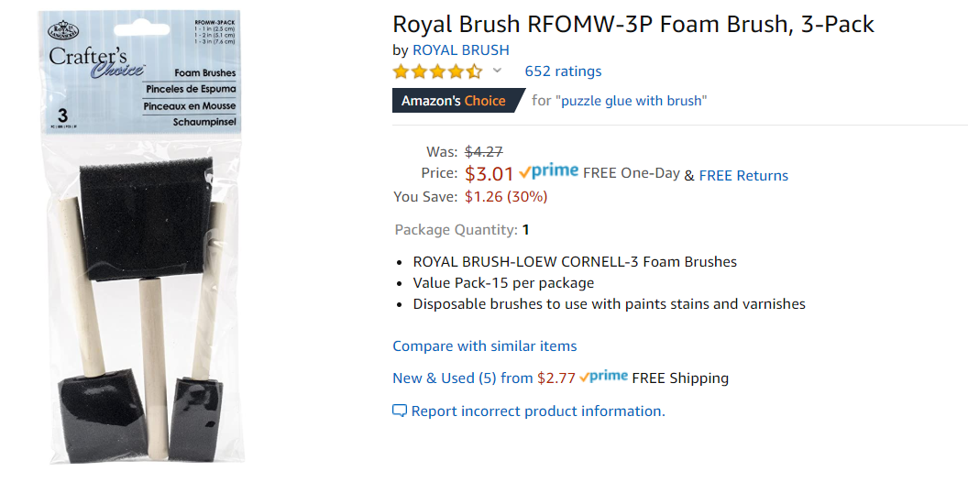

# Water Repellant for Shower Glass Closet

Water repellant to avoid water marks in the washroom glass closets. Available in Lowes for $6.48

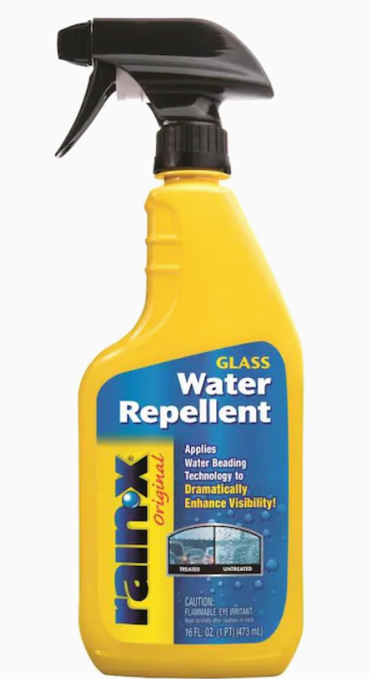

# Home Networking

If you opt to go with Windstream and need a router, this one works.

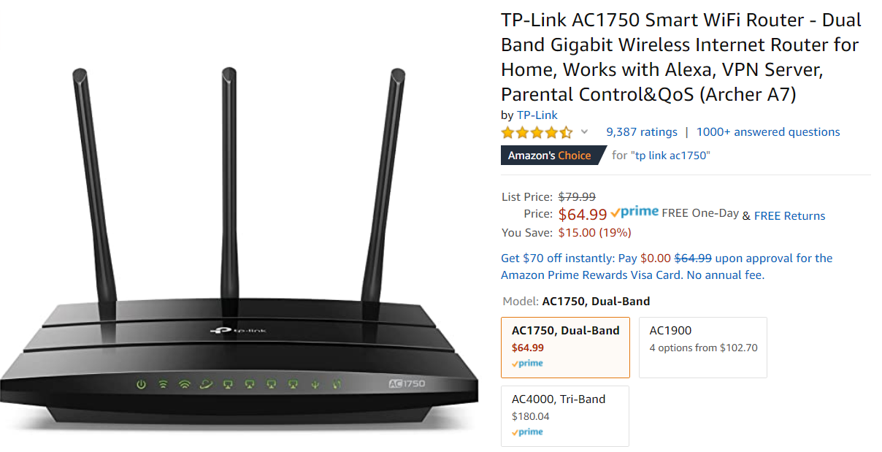

If you have opted for Ethernet links in the wall across your home and the builder has not provided connectivity, you would need a switch to get them live.

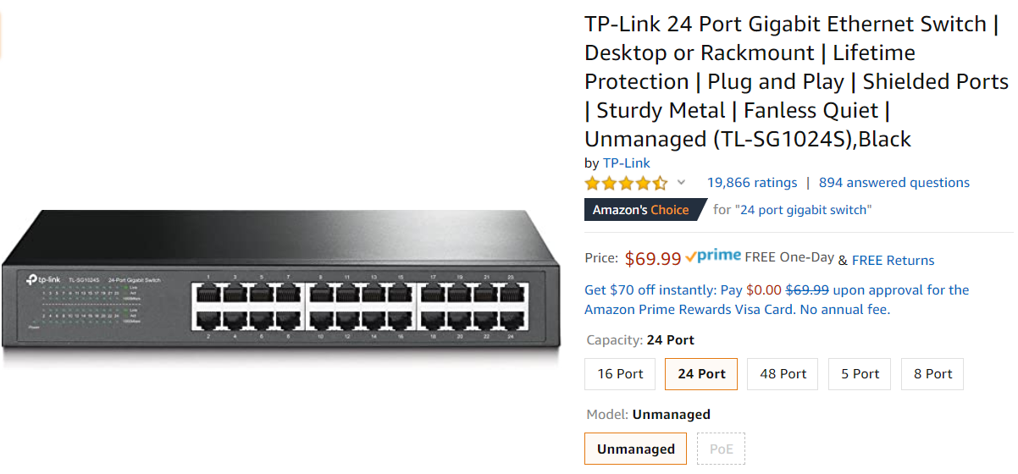

# Handyman Tools

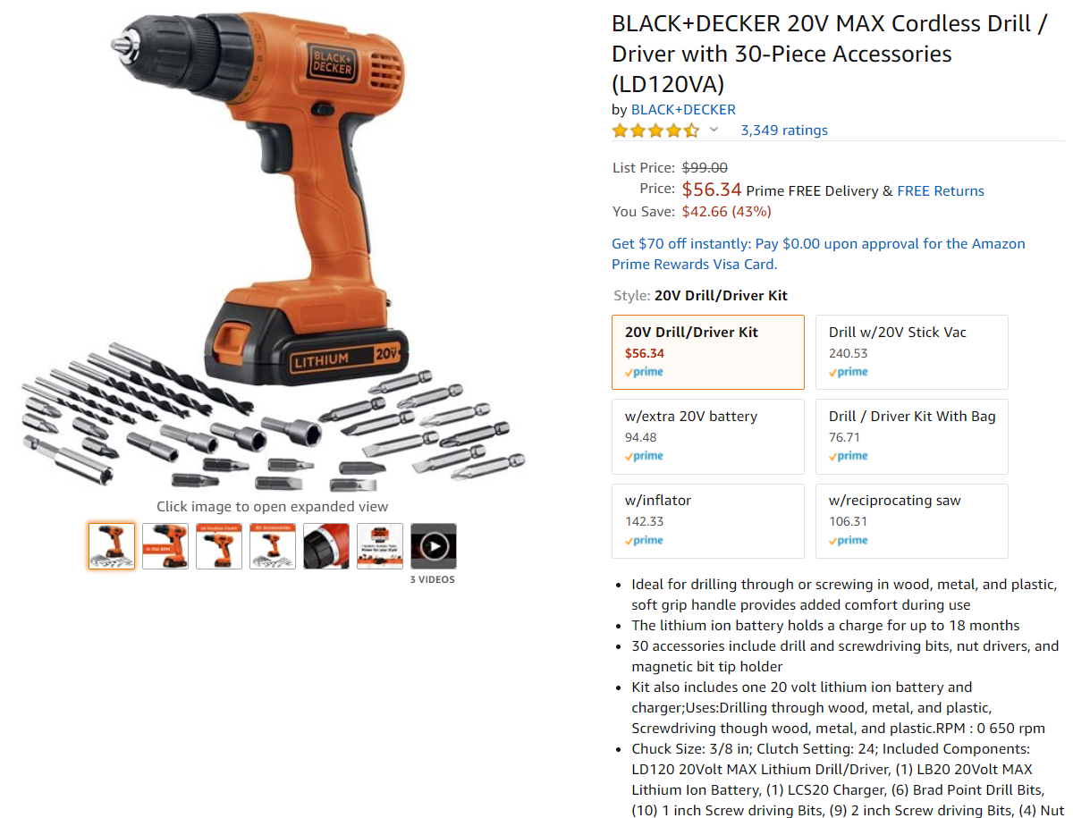

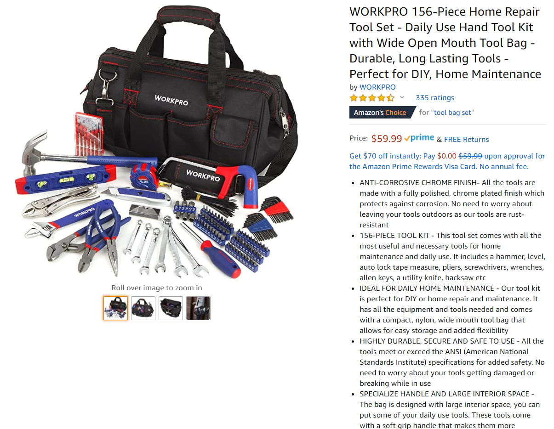

# Stop scratches on hardwood floor

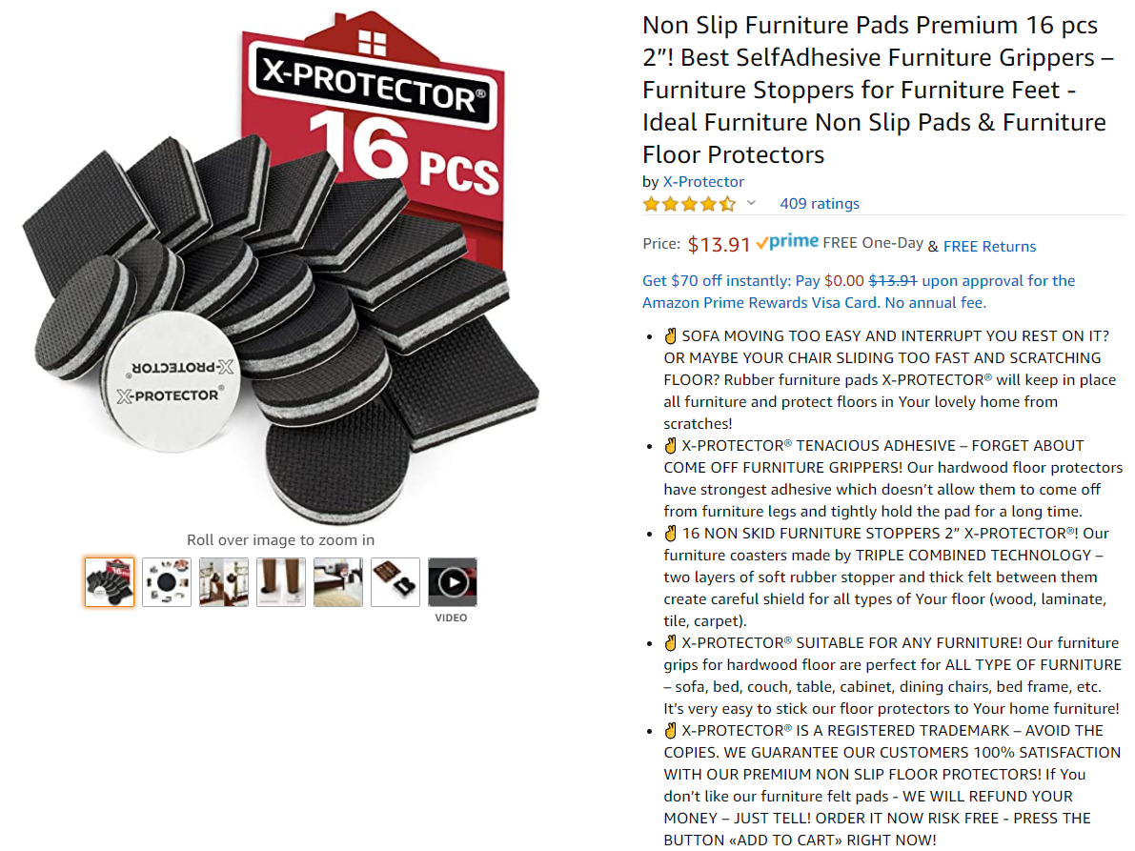

# TV wall mount

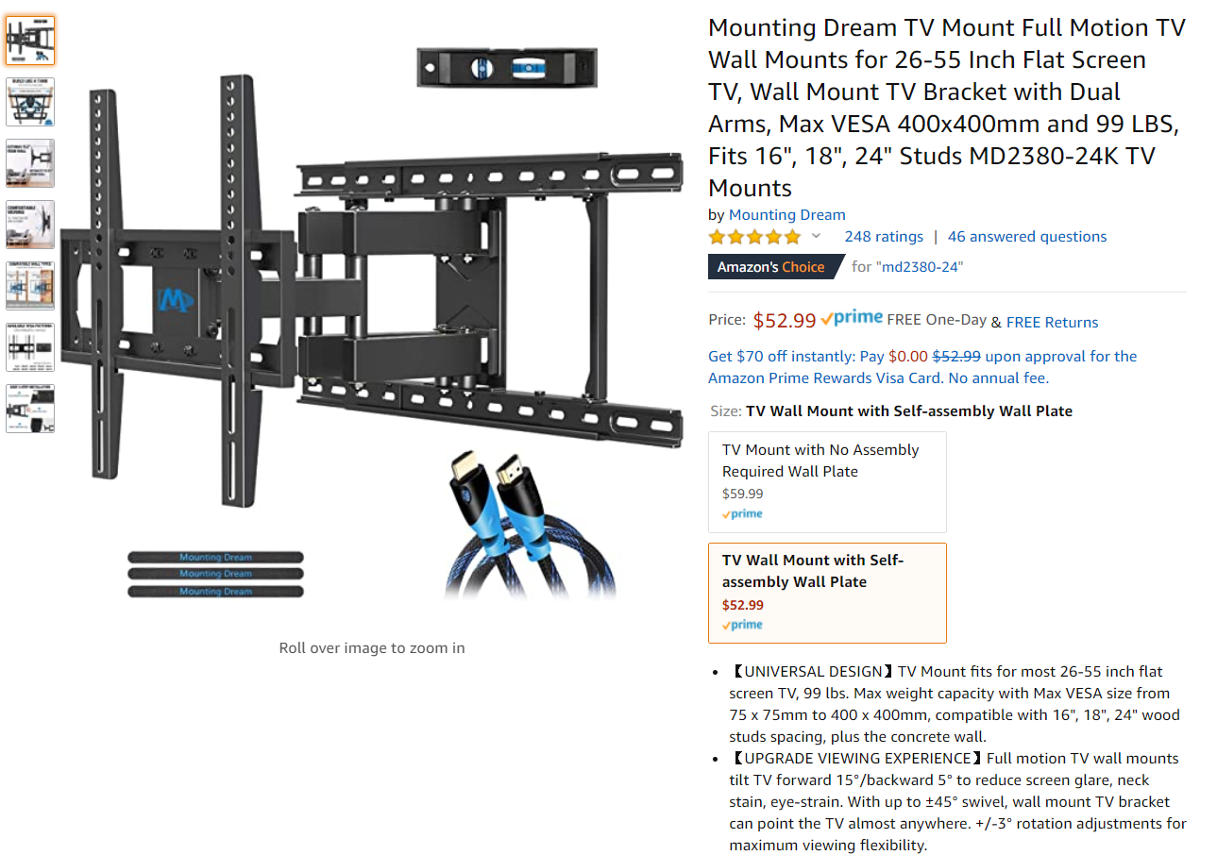

# Carpet Care

This is a good washer + dryer vacuum cleaner if you care to do a deep cleaning and washing

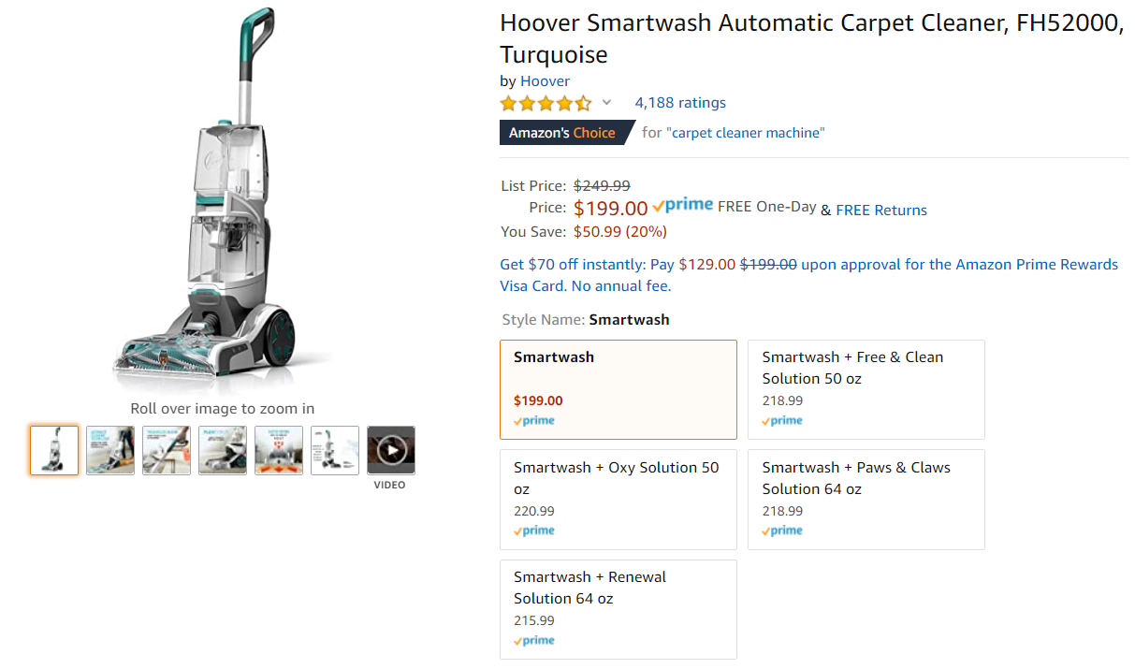

This is refill detergent for the Hoover Smartwash

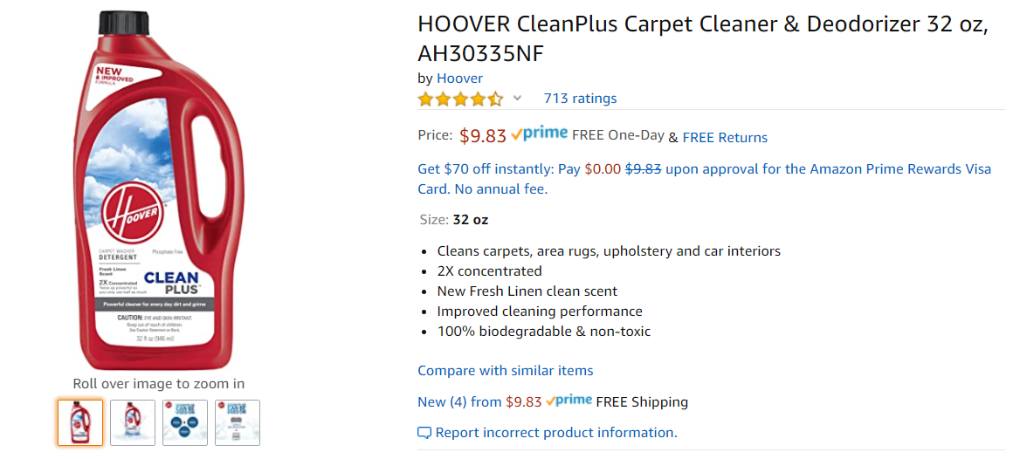

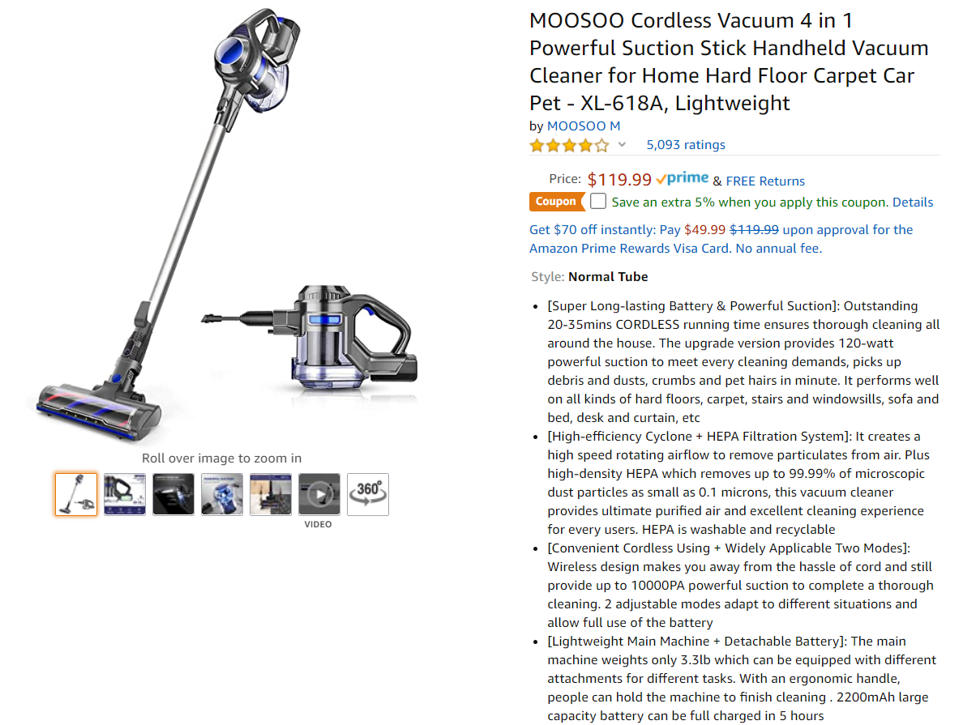

This is good solution to get rid of stains on your carpet as they happen. Available in Lowes for $5.38

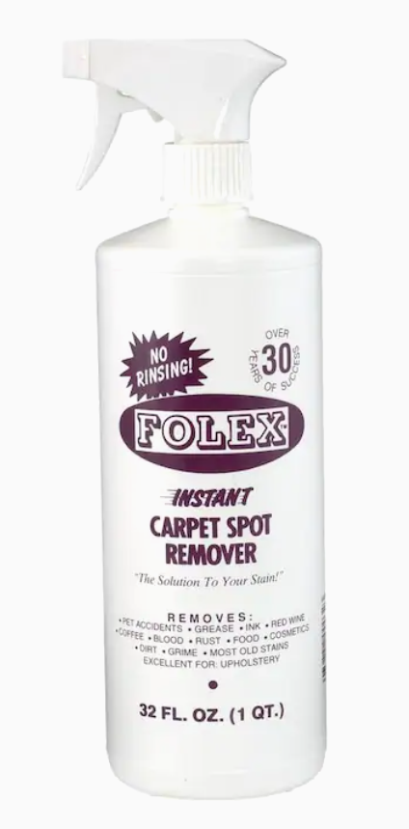

# Hardwood Cleaning

There are other cleaners available, but we preferred Bona to start with. We would want to explore RoboRock S6 mopper + vacuum cleaner and Shark Steam cleaner in the future.

